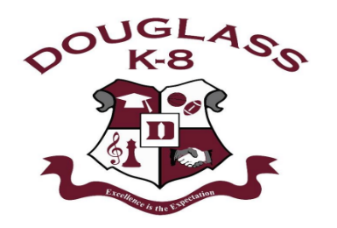

snip
STUDENT
CALENDAR
Douglass K-8 Optional School
1650 Ash St.
Memphis, TN 38108
901-416-5946
2024-2025 School Year

Sun | Mon | Tue | Wed | Thu | Fri | Sat
 |   1    NO SCHOOL! | 2  Football game v Lester Prep @ Whitehaven Stadium @ 5:30pm | 3 Progress Report Day!  Volleyball v Lester Prep @ Douglass HS 5:30p.m.      Girls Soccer v MBA @ May Field #4 6:00p.m. | 4  District MS WRITING TEST | 5 | 6
7 | 8  Volleyball v Maxine Smith @ East HS 5:30p.m.  Girls Soccer v MSE @ May Soccer Complex 5:00p.m. | 9  Football v Mt. Pigsah MS @ Cordova Stadium 5:30p.m. | 10  Girls Soccer v Memphis RISE @ Raleigh Bartlett Meadows Park 5:00p.m.  Volleyball v University MS @ Douglass HS 5:30p.m.  GRANDPARENTS DAY! |   11  District Parent-Teacher Conferences 4-7pm | 12 | 13
14 | 15  Volleyball v Memphis RISE @ Douglass HS 5:30p.m. | 16  Girls Soccer v Raleigh Egypt MS @ Raleigh Egypt MS @ 5:00p.m. | 17  Football v Craigmont MS @ Crump Stadium 5:30p.m.  Volleyball v MSE Cordova @ MSE Cordova 5:30p.m. | 18 | 19 | 20
21  HOMECOMING WEEK @ DOUGLASS K-8 | 22  Volleyball v Craigmont MS @ Douglass HS 5:30p.m. | 23  PLC Meeting during Planning  Football v Riverview MS @ Melrose Stadium 5:30p.m. | 24 | 25 | 26 | 27  Football v Lowrance @ Crump Stadium 7:00p.m.
28 | 29 | 30 | -Students are back in uniform each day!  -Homecoming flyer coming soon!  -Please stay in contact with your child’s teacher regarding their academic progress.  -If you have any changes to your phone number or address, please alert the front office team.  -Encourage your child to read at least 30 minutes per day!

